22.63: a) 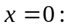 no field contribution from the sphere centered at the origin, and the other sphere produces a point-like field:
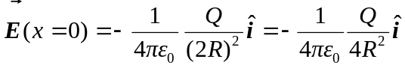.
b) 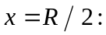 the sphere at the origin provides the field of a point charge of charge 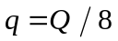 since only one-eighth of the charge’s volume is included. So:
c) 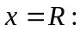 the two electric fields cancel, so 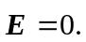
d) 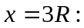 now both spheres contribute fields pointing to the right:
